EQ OCTAVE RESONATOR VST
Manual for Windows by aquanode (2026)

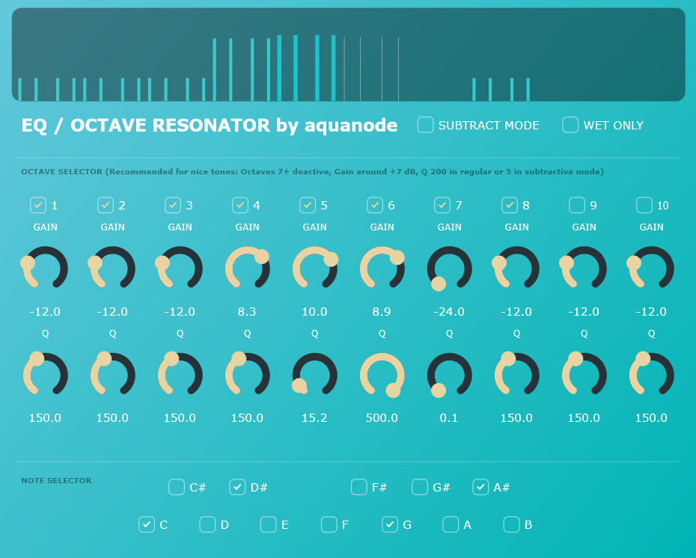

Personal / Copyright Message: This plugin is a passion project for the community. The plugin is free and the source code is open. Keeping things simple & fair, the rules are as follows:
Open Source: The code is free and open source. To compile from source, you need JUCE and Visual Code. You are welcome to modify the code and use it however you like, but do not sell it for money unaltered (sharing it for free is however encouraged!).
Official Support: If you don’t want to compile the plugin yourself, you can purchase it. The only official place to purchase the VST3 file directly is aquanode.gumroad.com for a recommen- ded amount of €3, but feel free to type in 0 and get it for free. Buying there ensures you have the newest, original files and my sincere thanks for your support.
Sharing is Caring: I don’t track licenses, so you may share the VST with your friends or reupload it for free to download on your website. If you see this plugin being sold for money anywhere else, then it’s a scam so be careful.
No Warranty: I am not responsible for any damages, and when you download the plugin from a third-party website, for malware or viruses. Use such versions at your own risk.
Thank you for your interest in my 2nd VST plugin, which I built with JUCE/Visual Code C++.

“EQ Octave Resonator” is basically an array of parallel bandpass filters with high peaks tuned to notes to sound musical. The unique feature of this plugin is that you can choose how many resonating octaves and notes should be actively enhancing incoming signals.

It is a VST equivalent of some earlier resonator effects I created in FL Studio’s Patcher that are free to download on aquanode.gumroad.com.

IMPORTANT NOTE: LOUDNESS WARNING

A Resonator may produce sharp, loud spikes in volume. When using it regularly in a DAW, such problems should not occur, but if you feed the already wet signal back into the VST it is very likely. Most software prevents this, but in standalone mode (i.e. when you compile the source code for a standalone .exe program) this might happen.

I thus recommend to have a limiter as next effect in your plugin FX chain.

Features

- A graphical representation of the bandpass filters is shown on top. There are bands for all active notes and octaves. The higher the Q (peak focus) value is, the more the band looks narrow and white, otherwise it looks wide and blue. The louder the octave is chosen, the taller the band. In subtractive (notch) mode, this behaviour is flipped, but please mind that notch filters always carve out frequencies completely so this flipped view is not 100% accurate.

- A subtractive / notch mode: This subtracts the chosen frequencies. For this to be audible, the Q factor should not exceed a value of 10, whereas 10 would be way too wide for the regular mode. Keep this in mind while switching back and forth between modes to avoid loud volume spikes.

- A wet only mode to hear ONLY the boosted frequencies instead of the boosted frequencies on top of the original signal. This only works in regular, not subtractive mode.

- The Octave Selector: Here you can choose the octaves where the resonator should work on. For musical, string like tones, you should disable the higher octaves (7 and up). Each octave has its own q and volume sliders, low values correspond to wide bandpasses, high values to narrow sharp peaks.

- And finally the Note Selector where you can check which notes across the chosen octaves should be boosted.

How to install
Next to the .vst3 and this .pdf, you will find 4 files with endings .h and .cpp in this folder. These make up the complete source code for JUCE, so you can compile and remake the whole effect plugin yourself if you like. Otherwise, you don’t need them.

As I do not own a Mac, only PC / Windows is supported. The plugin was tested on Windows 11 22H2, FL Studio 25, Ableton Live 11, and using Tracktion’s pluginval.
  - Download the zip file and extract it (you did this already).
  - Copy the .vst3 file into your system's VST3 folder. Usually, this is:
C:\Program Files\Common Files\VST3
  - Rescan your DAW’s plugin library (FL Studio, Ableton Live, etc.). The plugin should appear under the "Effects" or "Filter" category.
  - Add it to a mixer track, to which sound is routed.

explanations of the controls

- Subtractive Mode: If active, frequencies are damped instead of boosted.
- Wet Only: Only hear the difference in sound the resonators produce, without the dry signal.
- Note Selector: Select which notes you want to be affected (A4 = 440Hz).
- Octave Selector
  - 1 to 10: The octave which is actively resonated upon (C0 = 16.35 Hz to B9 = 15804.26 Hz).
  - Q: Low values are wide bandpasses, they may muddy the signal and can get loud overall, high values are sharp peaks. In subtractive mode this is the opposite.
  - Wet Gain: Attenuates or strengthens the wet (i.e. processed) sound.

Many thanks to Google for their Gemini AI that was indispensable for me to grasp how JUCE and C++ programming even works. It was a real time-saver, as I did not need to become an expert in all the details. The downside to that is of course that I’d still not be able to program a plugin without its help...
Fonts used in this Documentation: Aquatico, Bahnschrift, Conthrax.

